Step 1:
insert command in terminal:
1) sudo apt-get update -y
2) sudo apt-get install -y gnome-keyring

Step 2:
in VSCode click F1 or ctrl+shift+P for open command palette and search it:
- Preferences: Configure Runtime Arguments

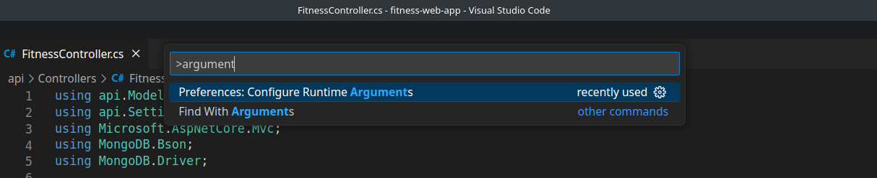
step 3:
add JSON in argu.json:
- "password-store": "gnome"

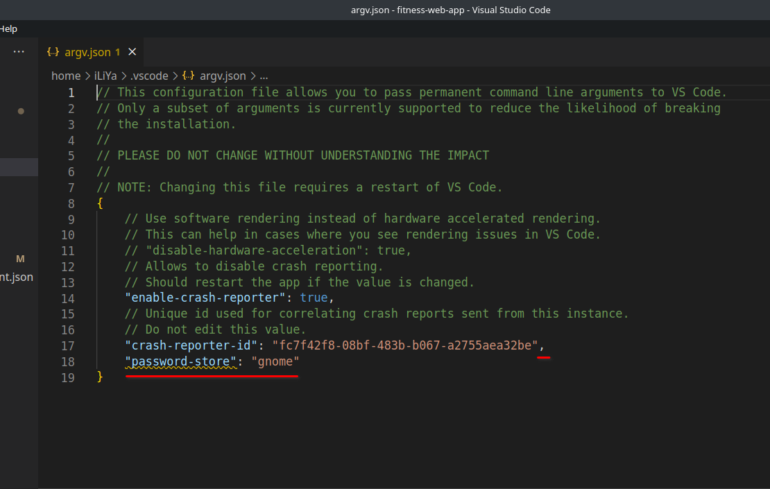

Finish

